

MSBA Capstone Program

Classifying the Coffee Quality with Aroma of Machine Learning Models

Submitted by:

Sai Srujana Jakkala

Sponsor[s]:

Prof. Mighty Itauma Itauma

December 15, 2024

Submitted in partial fulfillment of the requirements for MSBA degree

DeVos Graduate School of Management

Northwood University, Midland, MI 48640

**Executive Summary**

Coffee is one of the most consumed beverages in the world. Coffee is a kick start to their day in millions of households from many decades. Most of the people consider coffee as an emotion rather than a drink, it binds people together by creating memories, friendships, partnerships etc. Famous person once said “*Coffee is the drink of civilized people” – Thomas Jefferson.*

It is often said that “*good ideas start with brainstorming, but Great ideas start with a cup of Coffee”* so why not we serve the best quality coffee to the world with aroma of Machine learning models?

Let’s grab a cup of coffee and read this report on Coffee quality analysis…

Quality is an important factor in any food and beverage industry. I personally like exploring various coffees and often wondered how the quality of coffee bean differs from one another. With this curiosity, I started researching on the coffee quality and came across a dataset from the Coffee Quality Institute (CQI).

With increasing demand for coffee production and consumption worldwide, Coffee business is a highly competitive market with the revenue of US $461.20 bn as of 2024 makes me curious about gaps associated with the quality assessment of bean. This huge market is segmented with Premium and Regular coffee. Again, the brand segmentation is different, and consumers often prefer few brands because of its bean quality, taste and positioning in the market. Premium coffees are usually limited to about 10% of world coffee production i.e. Top-quality beans from the overall production.



Coffee bean quality assessment is important before exporting for cultivators, exporters, roasters to improve their business and market their products. There are many evaluation factors and physical attributes like aroma, flavor, acidity, balance, after taste, sweetness, moisture that influence the quality of the bean. Also, the geographical factors like soil, climate, altitude also influence the type of bean being produced.

The project aim is to use data driven machine learning models to classify the quality of the coffee into distinct groups that help the coffee producers focus on important factors that influence the quality and improve the production and marketers to segment the product as premium, quality and regular. Producing and testing the coffee bean at various level for achieving consistent quality is a challenge to the exporters.

By understanding the influence of various evaluation factors and its relations helps coffee industry produce better quality bean and take better decisions on production, cultivation, processing, marketing and quality assessment to serve best quality coffee to the consumer market and gain good market share.

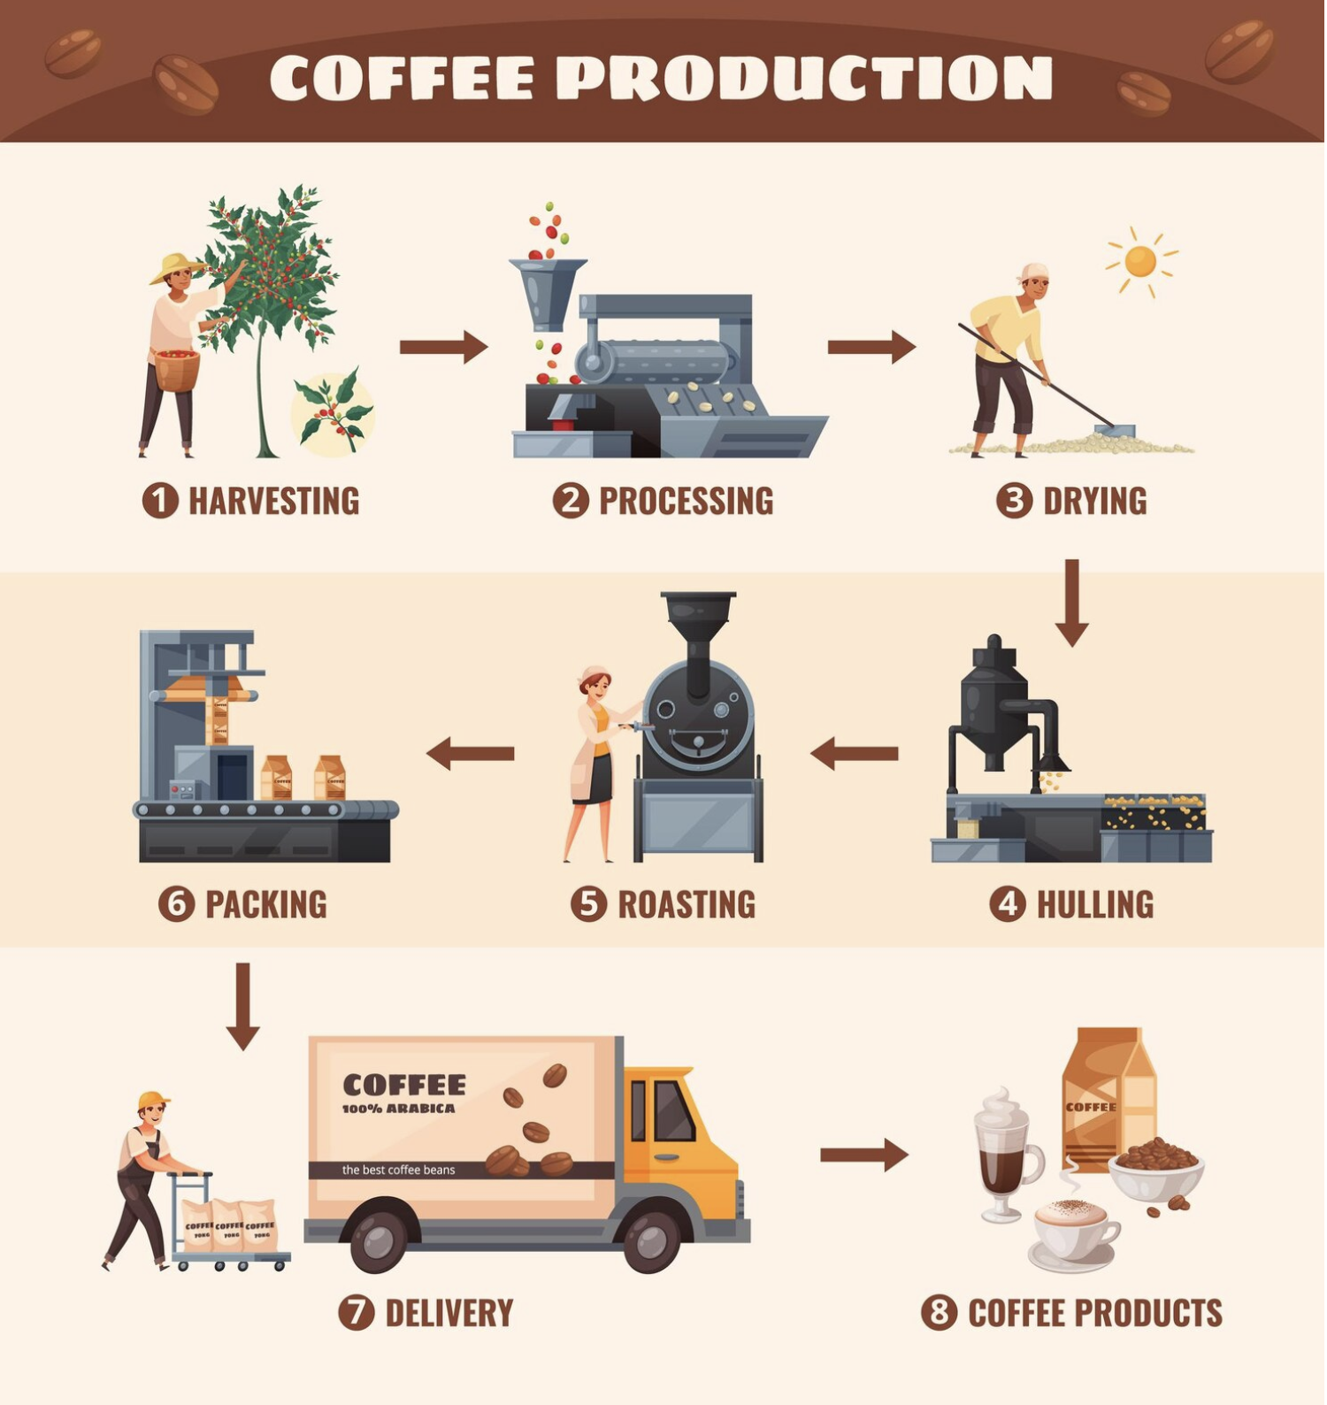

**Table of Contents**

|  |  |  |
| --- | --- | --- |
|  | **Title of the section** | **Page no** |
| **I** | **Introduction**   1. **Background of problem** 2. **Statement of problem** 3. **Purpose of study** | **5-6** |
| **II** | **Literature review** | **7** |
| **III** | **Methodology**   1. **Data overview** 2. **EDA analysis** 3. **Data preprocessing** 4. **Model building and comparison** 5. **Model evaluation** | **8-19** |
| **IV** | **Conclusion**   1. **Challenges** 2. **Key findings** 3. **Solution** | **19-20** |
| **V** | **Recommendations** | **20-21** |
| **VI** | **Future scope** | **21** |
| **VII** | **References** | **21-22** |
| **VIII** | **Appendix** | **22-24** |
| **IX** | **MSBA value assessment** | **24** |

**I. Introduction**

The introduction section begins with a brief discussion of the area of interest and then presents the following sub-sections:

1. **Background of the Problem:**

Coffee quality institute is a non-profit organization that works on improving the coffee quality and lives of the coffee cultivators internationally by helping them improve their quality in production and grade their coffee beans. They use a standard ‘Q grading’ system to evaluate the bean quality.

This helps in improving the communication between producers, buyers and distributers. The main challenges in the coffee production can be due to inconsistency in farming practices, climate change, soil and geographical locations and limited technological access to quality measures.

Machine learning algorithms can be used to analyze the important factors that impacts the coffee quality and the classify the coffee bean based on Q scale as the Premium and Regular coffees that helps in both optimizing the production process and improve the business segmentation that focus on the target customers.

1. **Statement of the Problem:**

Coffee being the most consumed beverage across the world and with the increasing demand for coffee worldwide, coffee bean quality assessment is important before exporting for cultivators, exporters, roasters to improve their business and market their products. There are many evaluation factors and physical attributes like aroma, flavor, acidity, balance, after taste, sweetness, moisture that influence the quality of the bean. Also, the geographical factors like soil, climate, altitude also influence the type of bean being produced.

The project aim is to use data driven machine learning models to classify the quality of the coffee into distinct groups that help the coffee producers focus on important factors that influence the quality and improve the production and marketers to segment the product as premium, quality and regular. Producing and testing the coffee bean at various level for achieving consistent quality is a challenge to the exporters.

By understanding the influence of various evaluation factors and its relations helps coffee industry produce better quality bean and take better decisions on production, cultivation, processing, marketing and quality assessment to serve best quality coffee to the consumer market and gain good market share.

1. **Purpose of the Study:**

The main aim of this report is to leverage the machine learning algorithms to classify the coffee bean based on its sensory characteristics like aroma, acidity, PH etc., that help in improving the production of coffee bean, cost reduction, automation of process, increase the quality and enhance the accuracy of evaluation process.

This ML technology overall improve the coffee farming practices there by helping farmers, distributers and marketers by covering the gap in the evaluation and production of coffee there by increasing the efficiency by automation.

This report explains about the role of machine learning in the coffee production and evaluation with detailed analysis on methodology there by increasing the scope for the research, identifying the gaps in the process through literature review, challenges and improvements where machine learning algorithms can be leveraged that bring in effective contribution to the field of Food and beverage industry by implementing technology and analytics.

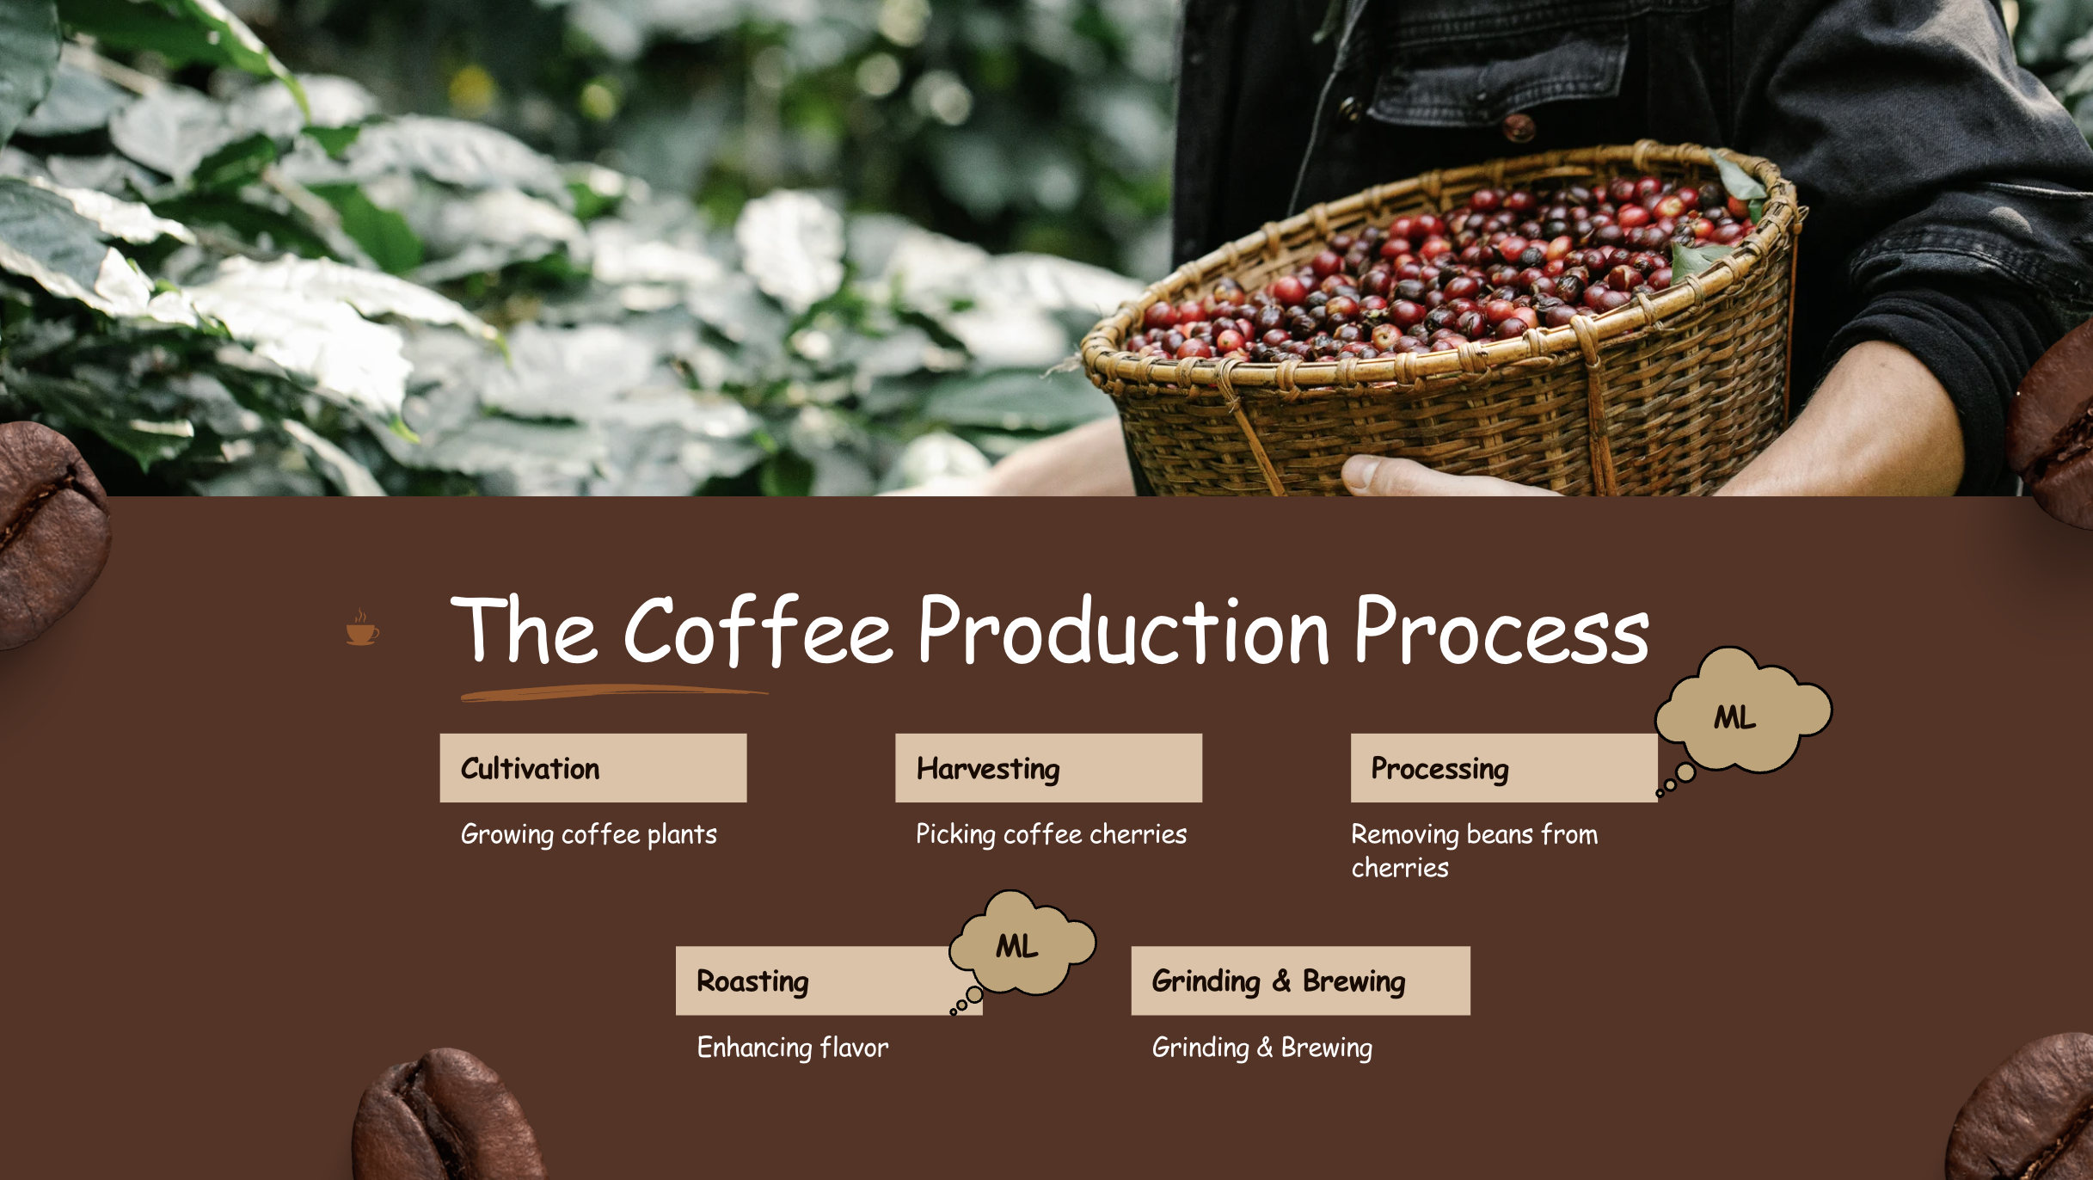

**II. Literature Review**

The literature review involves detailed understanding of few studies available in the relevant field or topic that I would like to do the analysis on. As a process of the literature review, I came across few research papers in which I will be discussing the three papers related to this topic.

1. **Paper 1: Prediction models for Arabica coffee beverage quality based on aroma analyses and chemometrics**

This paper explains about the arabica coffee that helps in research of sensory evaluation and chemical analysis. The coffee aroma profile was obtained by Gas Chromatography-Mass Spectrometry (GC-MS) where volatile compounds contributing to aroma were identified. Based on analysis few volatile compounds were strongly associated with higher sensory quality scores. This model explains good accuracy indicating reliable estimators.

1. **Paper 2: A comprehensive insight on modern green analyses for quality control determination and processing monitoring in coffee and cocoa seeds**

This paper explains about the modern analytical techniques used to coffee and cocoa seeds. The green analysis main aim is to minimize the environmental impacts and obtain high standard in quality control and processing methods.

1. **Paper 3: Correlating Espresso Quality with Coffee-Machine Parameters by Means of Association Rule Mining**

This paper used associate mining as the technique to identify the patterns influencing the espresso quality. The data was collected through IoT sensors embedded into espresso machines. This approach uses cloud-based analytics to provide real time insights.

There are other papers that uses various other techniques like computer vision, mass spectroscopy and there could be different insights derived from analysis. The computer vision technique can be effectively used to classify beans and identify defects but this machine learning classification techniques were comparatively limited and there is huge scope to dig deep into this technique.

**III. Methodology**

As I was researching about the coffee quality and available datasets on different platforms, I was able to get a detailed dataset from Coffee Quality Institute (CQI) where the dataset has information of both Arabica and Robusta coffee from various countries across the world. I found this dataset to be ideal and good start for quality analysis of the project. CQI is a non-profit organization working towards the betterment of the coffee quality and improving the life of people involved in production to preparation. They are thriving towards improving the efficiency of coffee production and the people involved in it.

In this section, I will be discussing in detail about the Dataset overview, EDA analysis, Data preprocessing, model building, model evaluation and Metrics used for analysis.

1. **Dataset overview:**

The dataset has comprehensive information about the physical attributes and chemical compositions of coffee bean produced. There were about 43 independent variables with target variable being the “Total cup quality”. The independent variables include:

* Coffee characteristics (Species, Variety, Processing Method)
* Origin information (Country, Farm, Region)
* Quality scores (Aroma, Flavor, Aftertaste, etc.)
* Production details (Number of Bags, Harvest Year)
* Altitude information
* Certification details

There are two different types of coffee arabica and robusta. The datasets have both categorical and numerical variables with target variable being numerical that helps measure the quality.

1. **Exploratory data analysis (EDA):**

The main step includes importing the libraries and reading the data. The data has about 43 variables and few can be removed, and the variables required for the analysis of the problem statement can be retained for simplifying the analysis. After dropping the other variables, I checked for missing values in the data.

Using the technique of mode for numerical variables and majority occurrence for categorical data, I was able to treat the data. With this the missing values were handled for checking the data exploration.

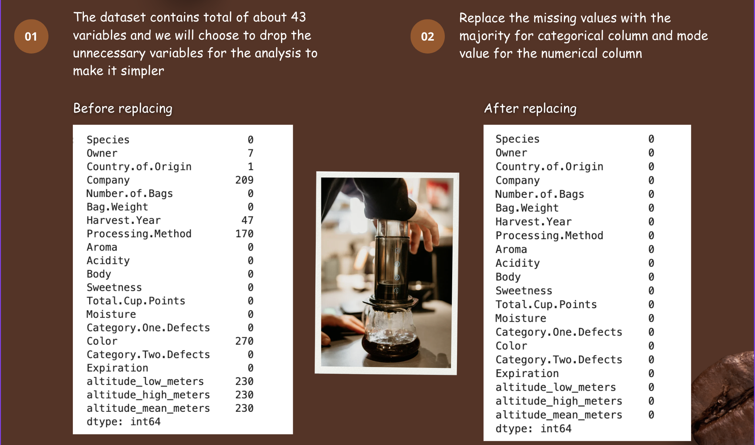

Next step is to analyze the data using visualization graphs, by understanding univariant and multivariant analysis for the data, gives clear picture of important variables.

**Univariant analysis:**

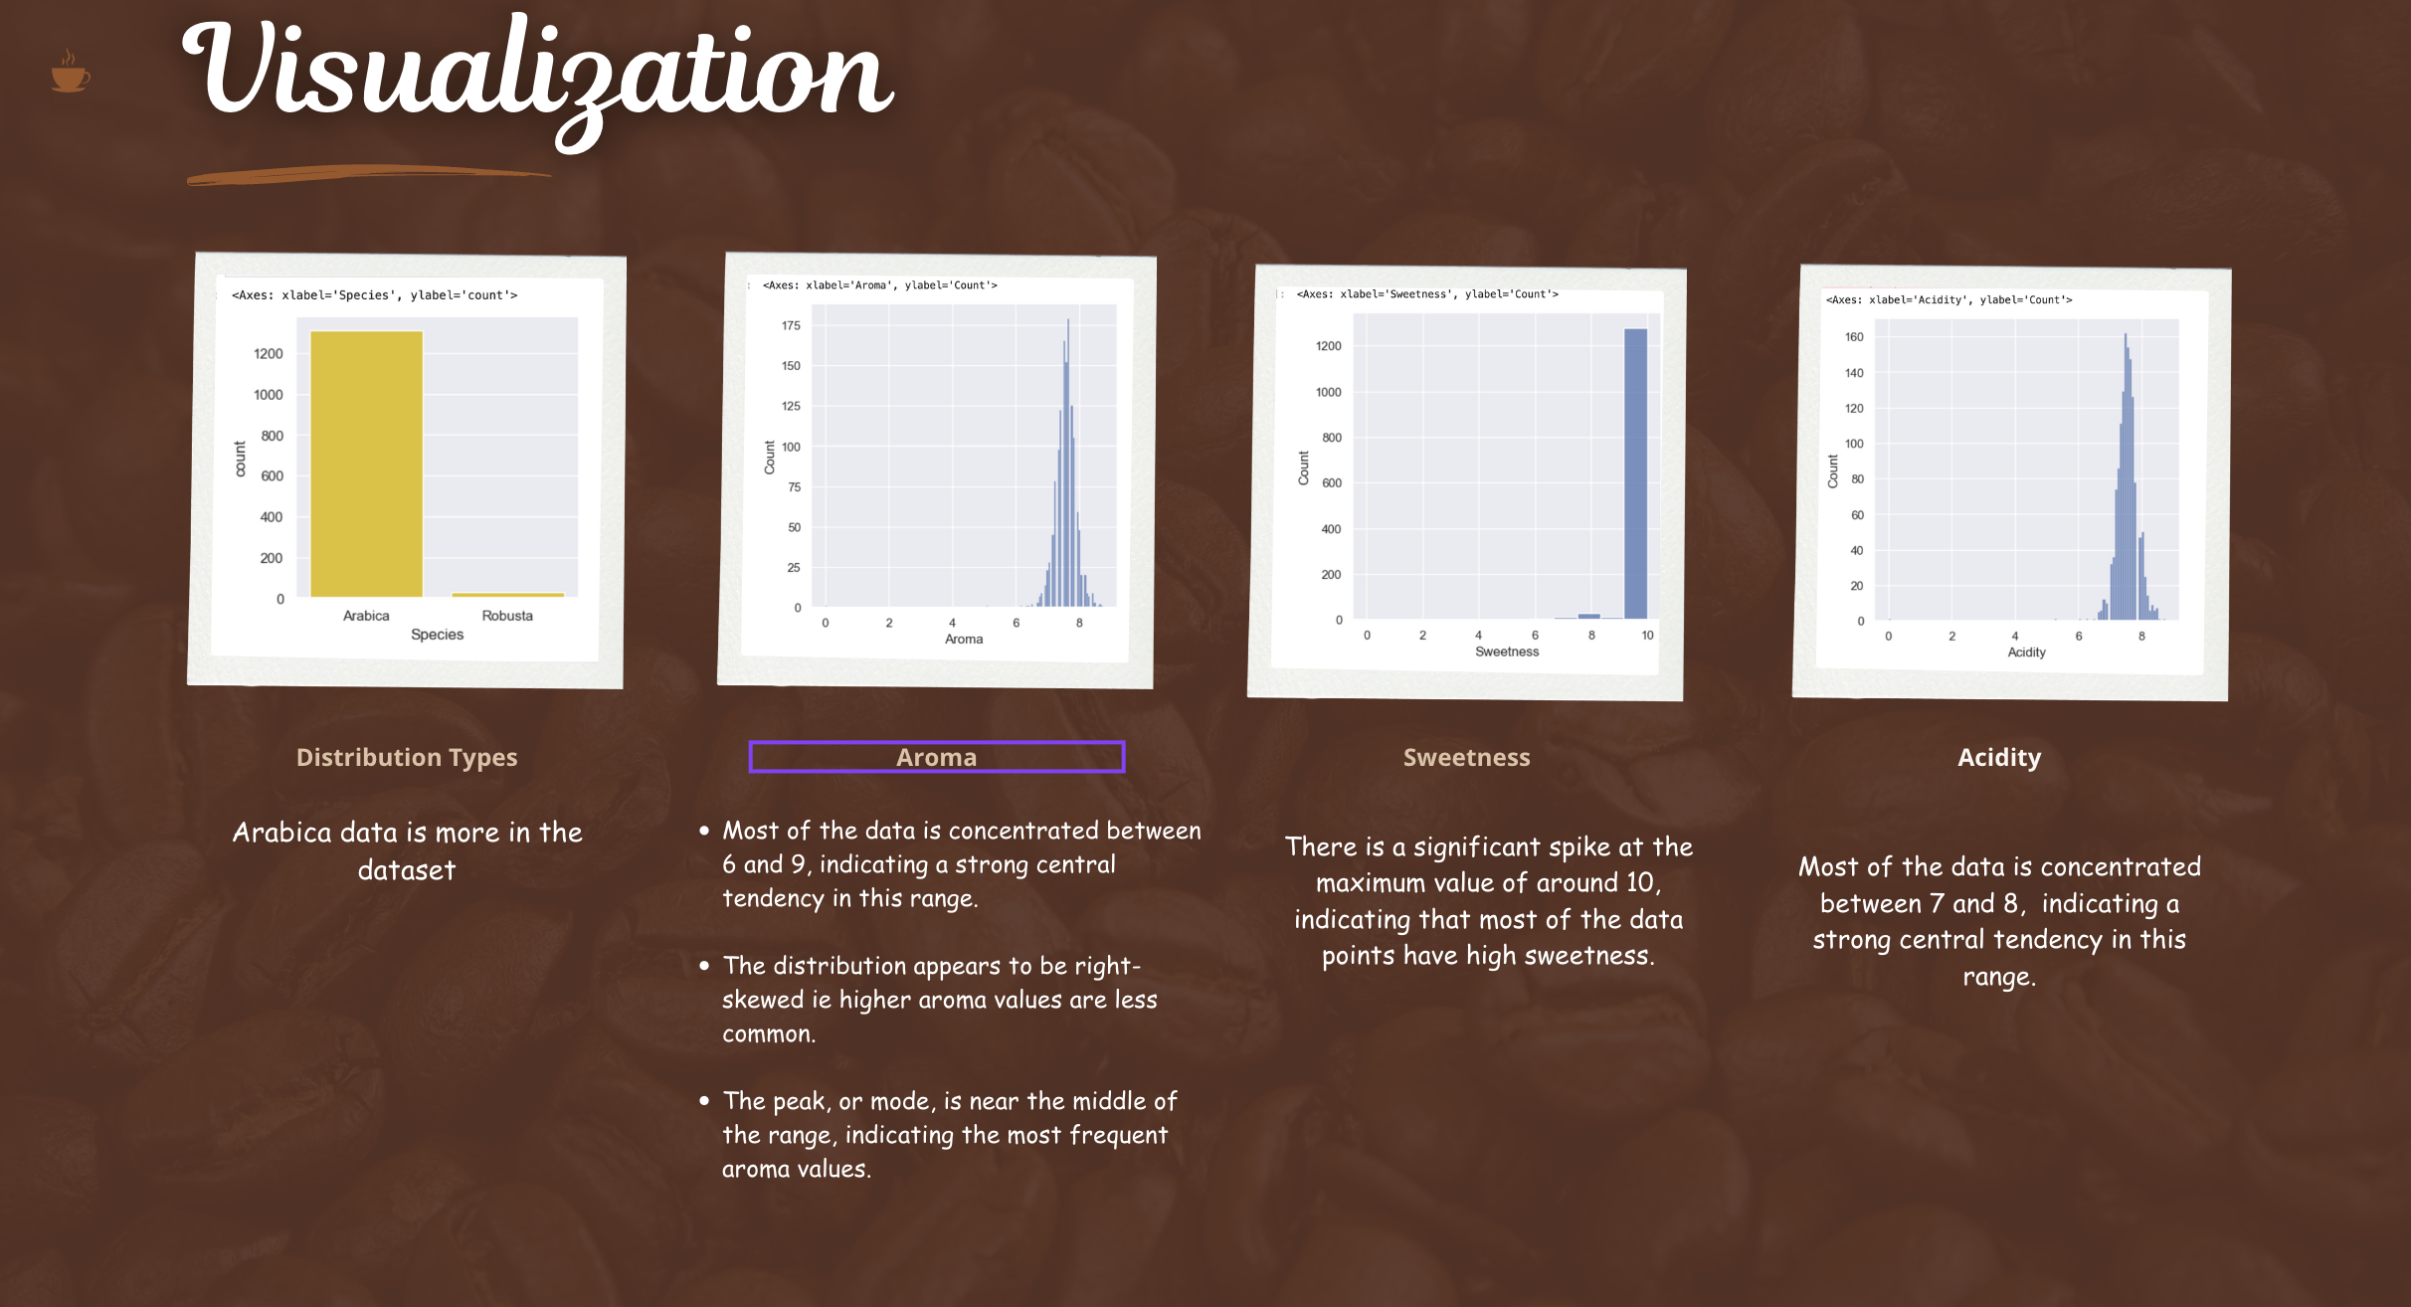

**Multivariant analysis:**

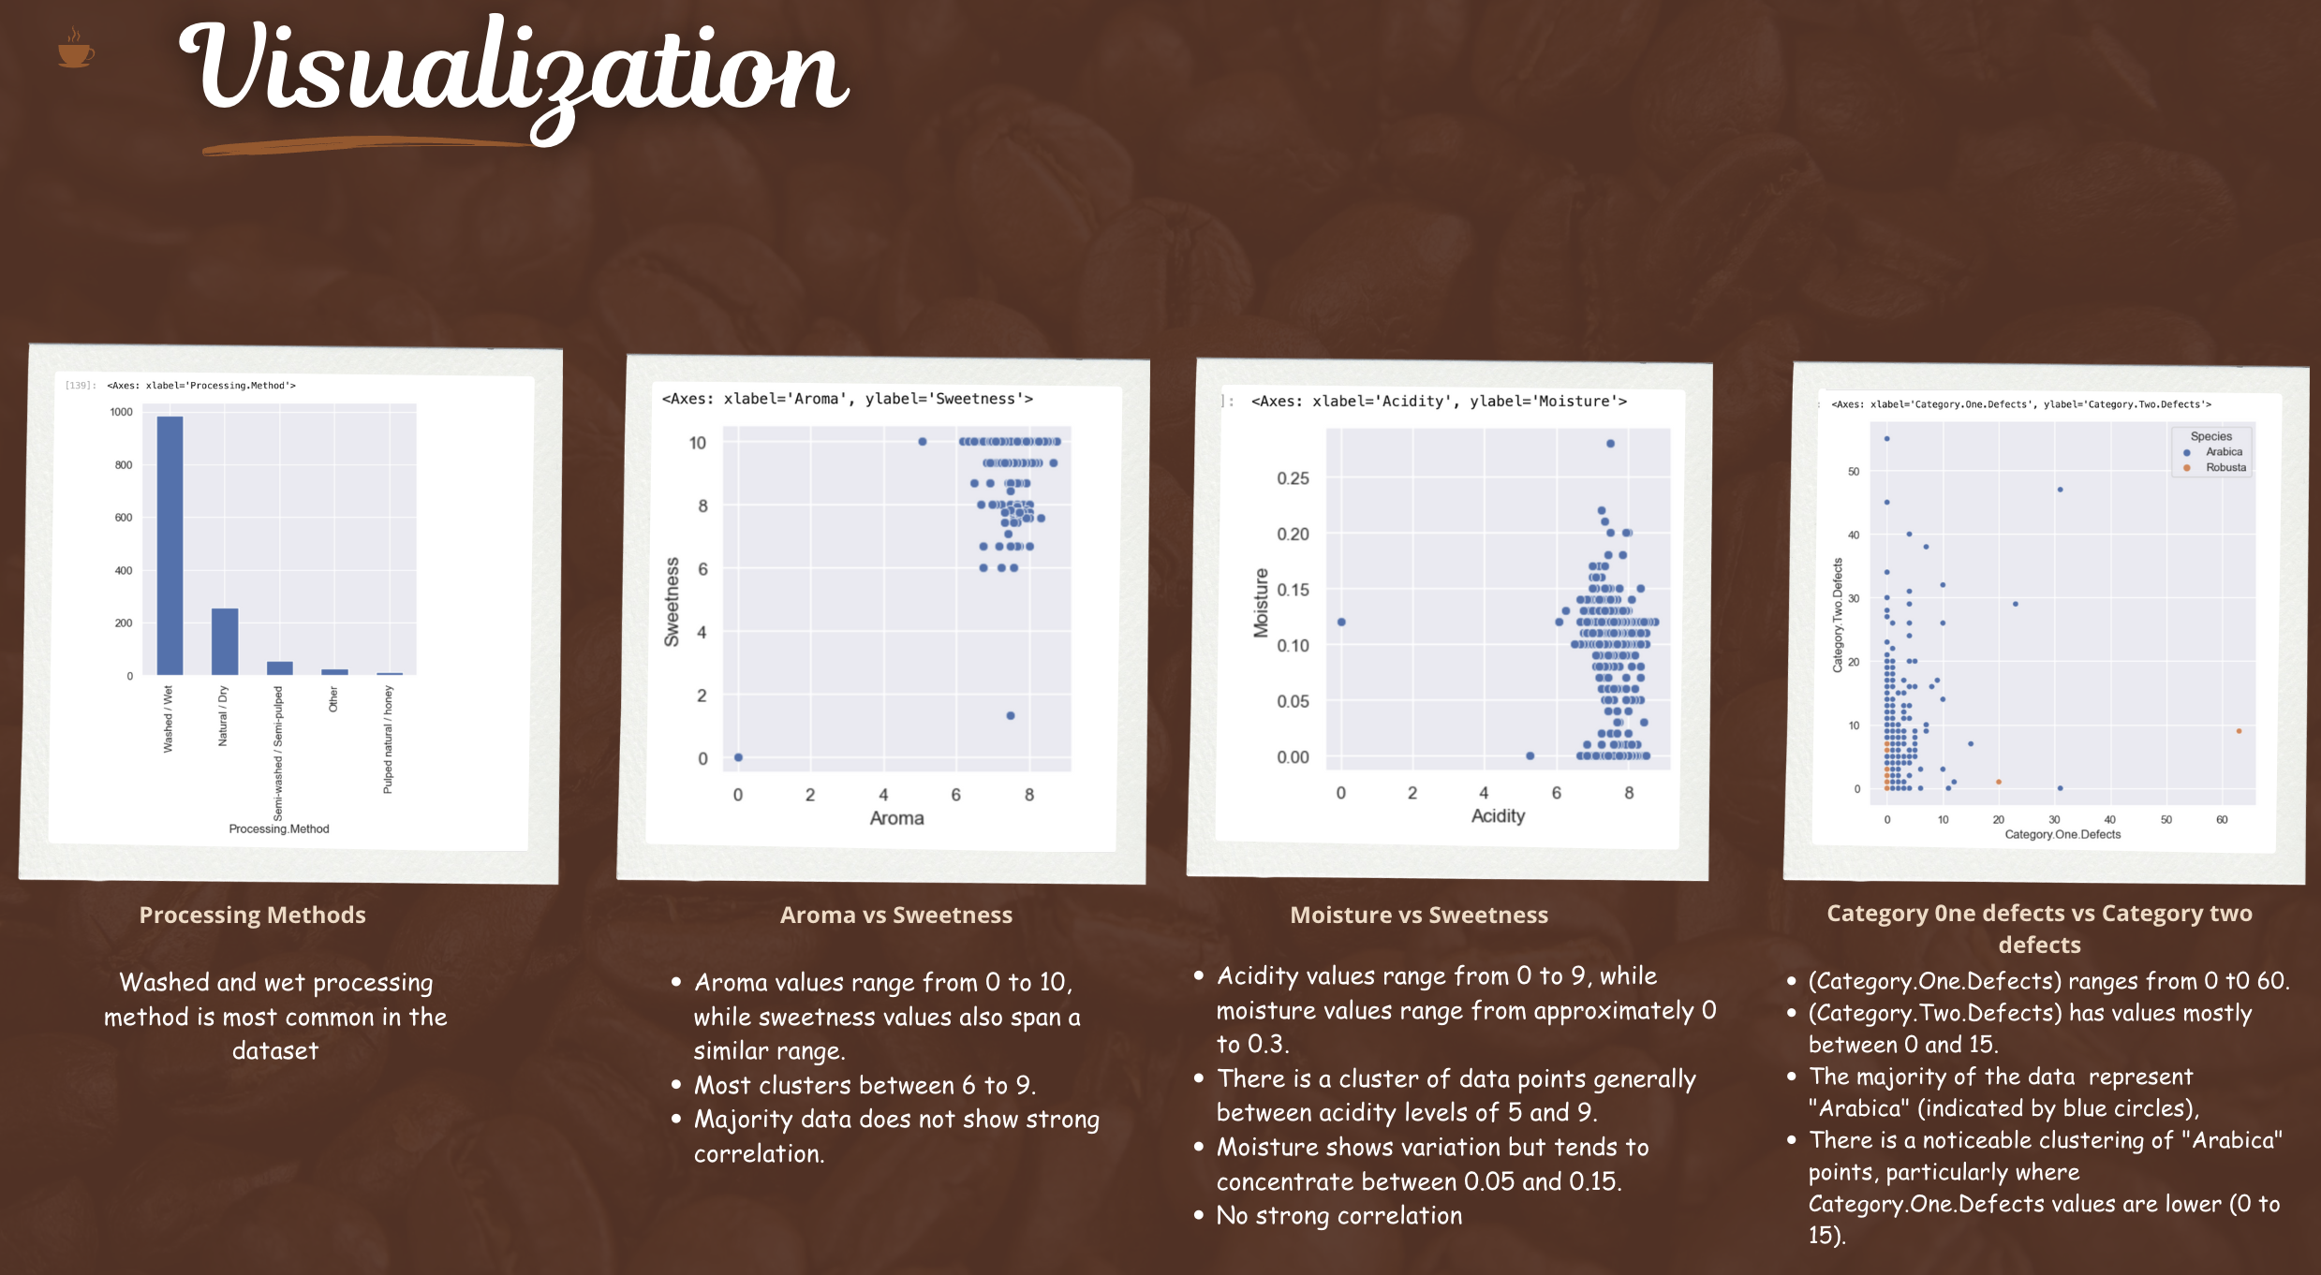

After this, I wanted to understand the correlation of the dependent variables with the target variable. Here Total cup quality is the target variable to understand the coffee quality scale.

Also, understanding the distribution, the Arabica coffee type is more than Robusta with only minimal data that can be ignored or dropped from data to simplify the analysis. So, I dropped the robusta entries and the variable type for better analysis.

**Correlation Matrix:**

Analyzing the most important factors influencing the coffee quality, the characteristics Aroma, Acidity and Body has strong positive correlations whereas altitude, moisture content and sweetness has week correlations.

The other physical attributes show minimum correlation that explains quality score is more dependent of sensory characteristics like aroma, acidity and body factor rather than physical attributes or production quantities.

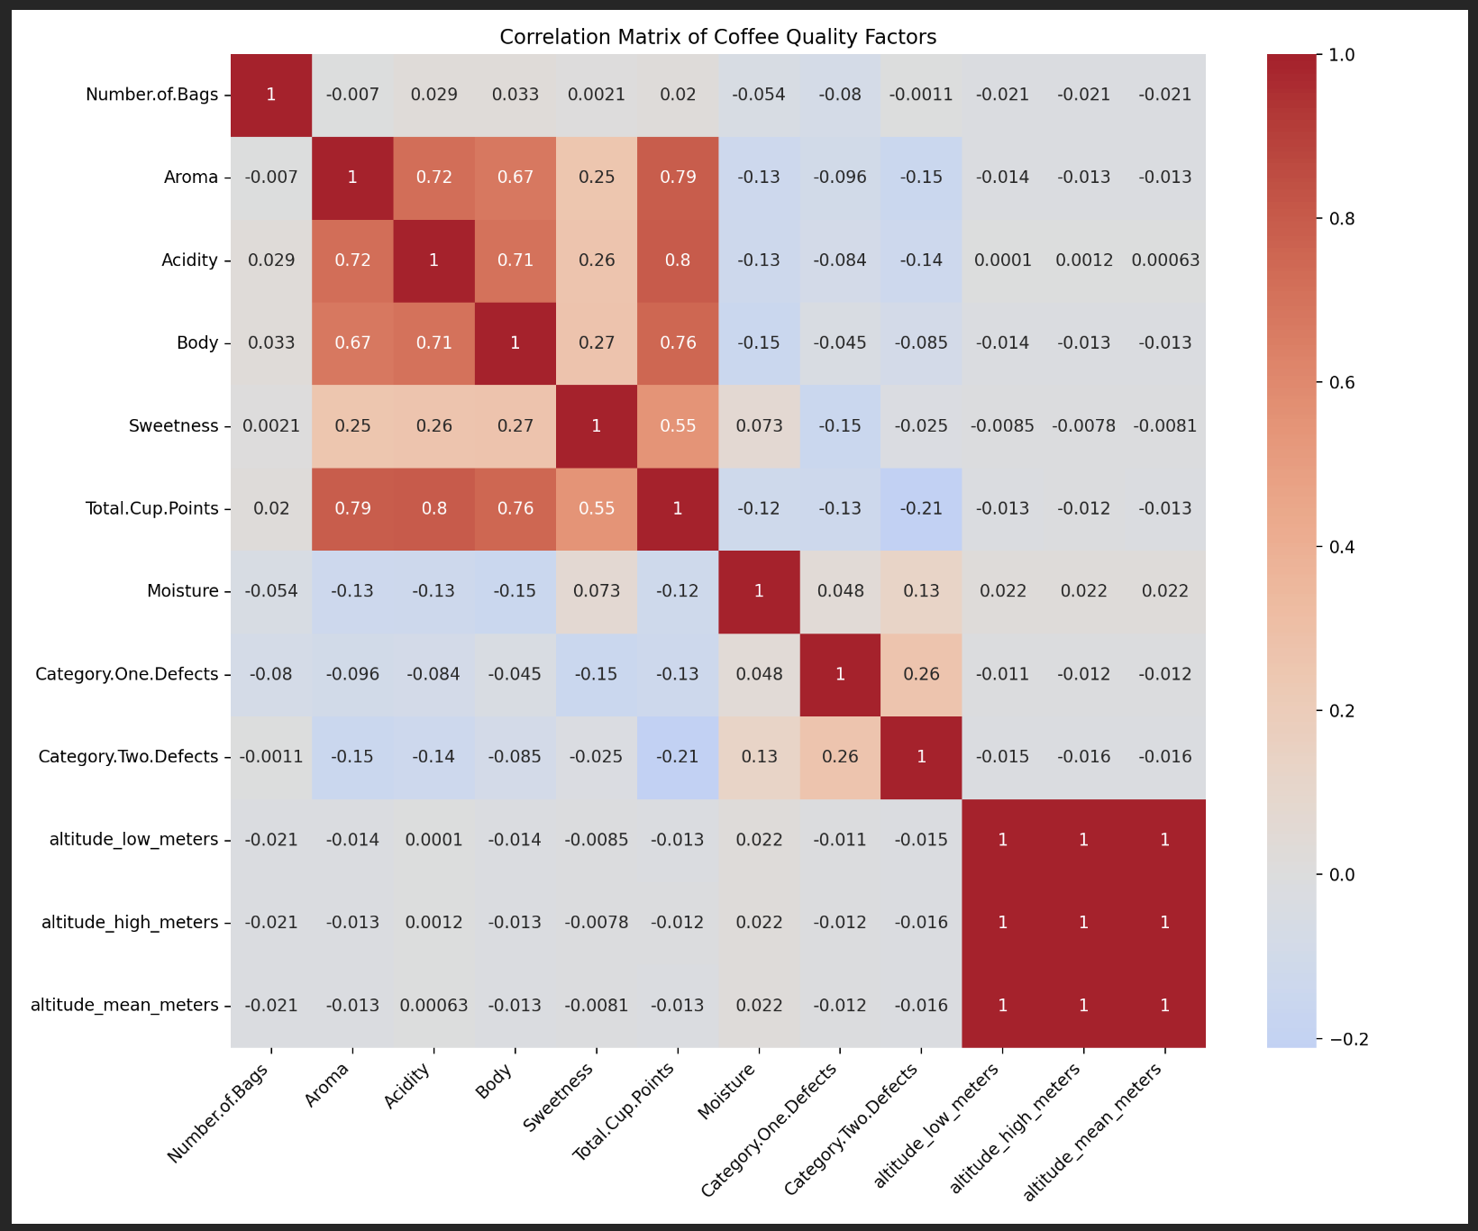

1. **Data Preprocessing:**

The data preprocessing includes handling missing values, feature selection, label encoding, scaling data, splitting the data.

1. **Handling missing values:** This step is already performed before EDA analysis
2. **Feature selection:** This means identifying and retaining only the relevant features for analysis based on the correlation.
3. **Label encoding:** This means encoding the target variable (Total cup quality) as binary and dividing it into classes for model building. Here the variable is split into 2 classes with 0 as regular with score of <=80 and 1 as premium with score of >80.
4. **Scaling the data:** Standardizing the numerical variables using the standard scaler function that helps ensure all the variable are on similar scale. This helps minimize the bias
5. **Splitting the data:** The data is split into train and test sets for model building with 80% of data for training and 20% of data for test set with random factor of 42.
6. **Model Building and Comparison:**

After detailed analysis of data and preprocessing, I performed various analysis like clustering and classification. Let’s understand this in detail.

* 1. **Clustering Techniques:**

In clustering analysis, first used normalization technique and performed dimensionality reduction of PCA (Principal component analysis). After this used K-means clustering with n=3 initially and then increased the clusters to n=5. The clustering analysis distinguishes better in n=3.

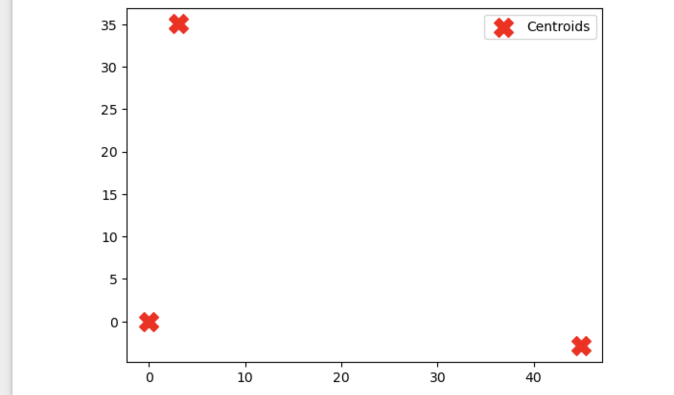

Then I performed the elbow method for optimizing the K value. After performing the technique, I analyzed that the Silhouette Score for K-Means clustering is 0.1249 which indicates that there is overlap in between the clusters and require further data tuning.

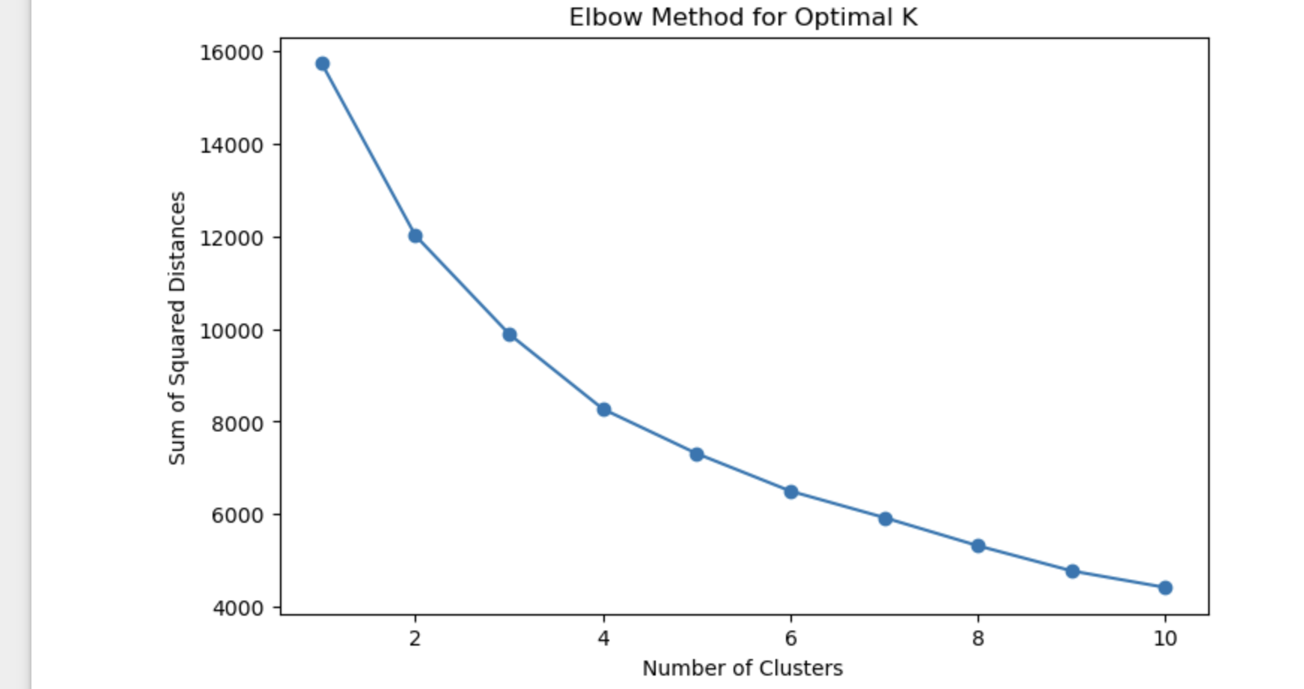

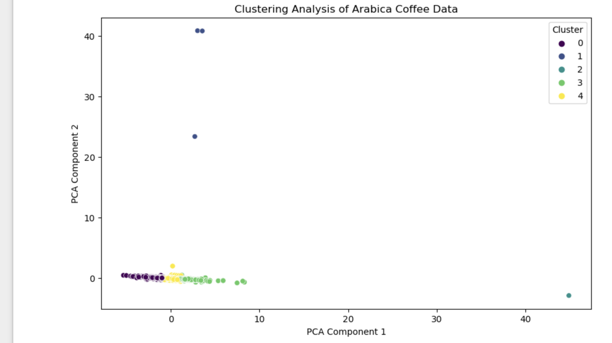

With this I understood that this technique is not ideal for this data and proceeded with classification technique.

* 1. **Classification Technique:**

After splitting the data into training and test set and distinguishing the classes as premium and regular coffee, I performed the multiple models to understand the best model by analyzing the metrics of Accuracy, Recall, F1 score etc.

By analyzing various models and their confusion matrix, the Support vector model(SVM) has the highest accuracy of about 94% followed by Logistic regression accuracy of 93.91% and Extra trees classifier with accuracy of about 93%. These models can be considered the best models for analysis specifically the SVM model.

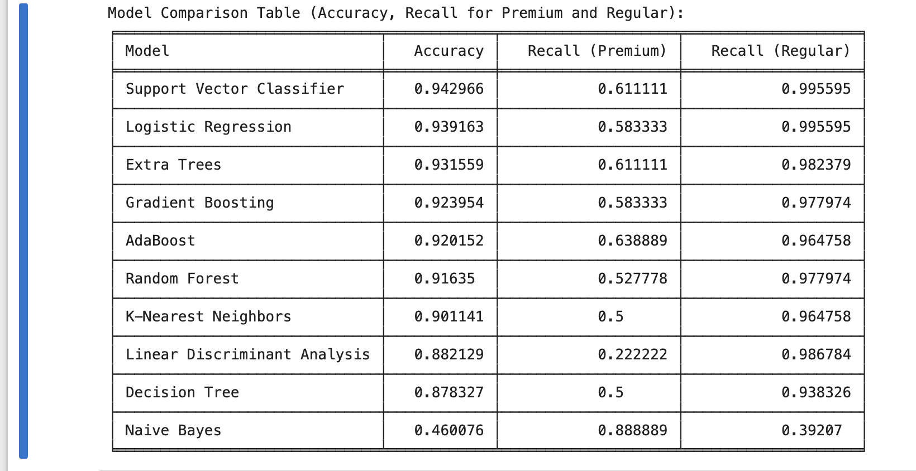

**Model comparison table**

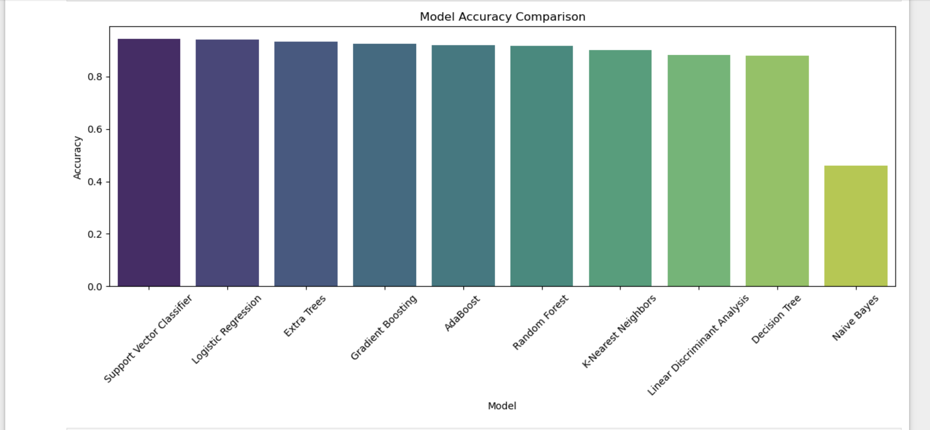

**Model comparison graph**

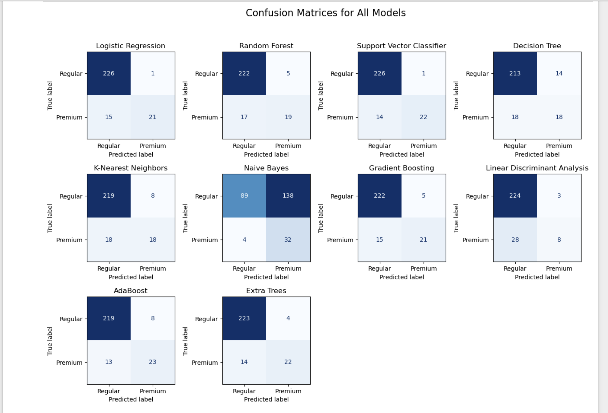

**Confusion matrix comparison**

After understanding the comparison, I can say that the accuracy metrics is better for regular class but does not have high accuracy for premium class which means the accuracy metrics is not distinguishing well for premium class and it distinguishes well for regular class. This is because of imbalance in the data.

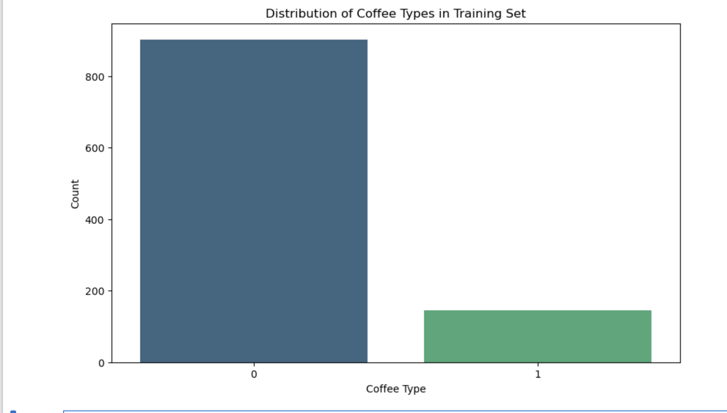

This clearly explains that data is highly biased towards regular with premium quality coffee is minimal. So, accuracy metrics is not ideal metrics for this method.

To eliminate the bias in the data, I must either follow the SMOTE analysis to balance the data with some false values or switch to an alternative metrics of AUC-RUC curve metrics.

* 1. **AUC – ROC Curve:**

This Area under curve – receiver operating curve is single scaler between the value 0 and 1. This is an ideal metrics to eliminate the bias in the data as it only considers the **TRUE POSITIVIES** for analysis and calculation of metrics.

The interpretation is:

* **AUC = 1:** Perfect classifier (no false positives or false negatives).
* **AUC = 0.5:** The model is no better than random guessing.
* **AUC < 0.5:** The model is performing worse than random guessing

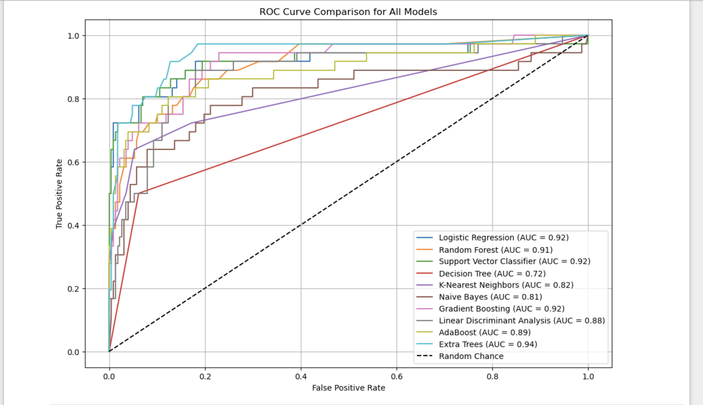

The area under the curve interprets in the following aspects:

* AUC-ROC explains how well a classifier can distinguish between the positive and negative classes.
* It evaluates the model across all possible thresholds for classification and shows its ability to discriminate between classes.
* Higher AUC indicates that the model is better at distinguishing between classes, even with changing decision thresholds.

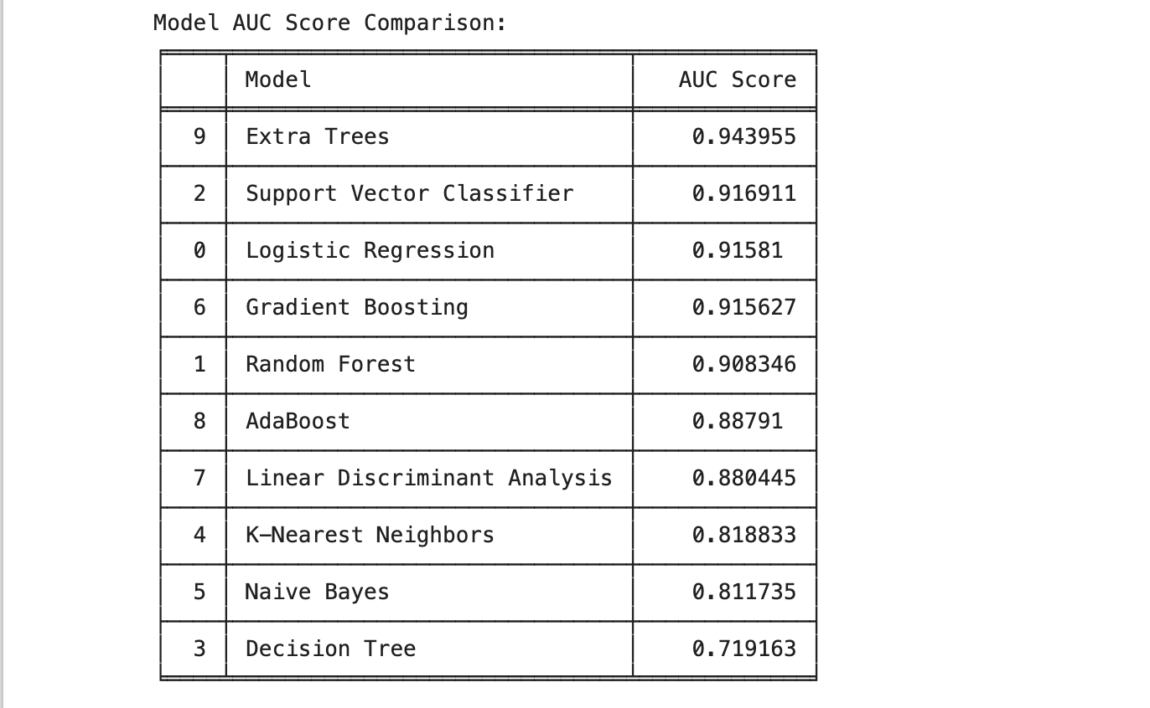

**AUC-ROC Comparison of Models**

By performing the AUC-ROC curve model comparison, Extra trees model has 94% score followed by SVM and logistic regression classifier with score of 91%. This method is particularly effective when there is imbalance in the data or optimized for trade-off between false positive and false negative.

1. **Model Evaluation:**

By analyzing various techniques and models for comparison and identifying the best techniques and models, I can say that AUC-ROC Metrics is the best method for this dataset as it is able to distinguish between the positive and negative classes.

Accuracy metrics is simply the percentage of correct predictions made by the model. It can be misleading, especially when there is an imbalanced dataset (e.g., when one class is much more frequent than the other)​. AUC-ROC is particularly useful when the classes are imbalanced or optimize for a particular trade-off between false positives and false negatives.

* 1. **Advantages of using AUC-ROC metrics:**
* **Imbalanced Data:** AUC-ROC remains a better metric as it takes both classes into consideration, explaining how well the model distinguishes between them.
* **Threshold Sensitivity:** AUC-ROC evaluates performance across all thresholds, explaining a better model performance.
* **Threshold Flexibility:** The ROC curve helps explore how the model performs with different thresholds (e.g., adjusting for higher recall or precision).
  1. **Findings from the evaluation:**
* AUC-ROC explains how well the model can distinguish between classes, independent of the threshold, while accuracy tells you the % of overall correct predictions at a fixed threshold.
* AUC-ROC is better at revealing this when the dataset is imbalanced or when you need to evaluate the model's behavior across different decision thresholds.
* **Extra trees model** has AUC ROC can provide more insight by evaluating the model's performance across various thresholds, not just a fixed classification boundary.
  1. **Extra Trees Model:**

This is the best model for the dataset with higher AUC-ROC curve. Extra trees are similar model to Random Forest and is an ensemble method that works with combination of multiple decision trees. This model works with collection of decision trees with each tree trained on random split. This uses bootstrap sampling making the model more versatile.

1. **Advantages of Extra trees:**
   * It has high randomness with good generalization that reduce variance and overfitting. Randomness makes the data more robust for analysis.
   * This model uses random thresholds at different nodes making the training faster for the data.
   * Extra trees perform better on the high dimensional data with more features and this dataset initially has many features

**IV. Conclusions**

This project methodology revolutionizing the coffee quality management that explains a detailed and robust analysis of coffee quality classification using various Machine learning techniques. By implementing analysis for a Coffee Quality Institute dataset and performing a good classification technique by distinguishing the data into classes of Premium (>80) and regular (<=80) for the coffee bean.

A good EDA approach, effective preprocessing of data with correct model building and evaluation using multiple metrics helps explain the best technique and metrics required for is analysis that helps improve the efficiency of coffee evaluation process. The right interpretation of metrics using AUC-ROC curve ensures a decent identification for premium coffee and is effective to handle the imbalance in the data. The Extra trees model provides better generalization, making this metrics a good method for real- time assessment.

This machine learning in the real time quality assessment helps provide efficient and data driven approach to improving the coffee production.

**The main Challenges are:**

* **The data quality:** the overall data quality is good, but the Arabica coffee type is much more than robusta because of which the less data was removed for better analysis.
* **Data Imbalance and bias:** The data is highly imbalanced with regular coffee being more compared to premium coffee.
* **Model Drifting:** The ML models used may not always perform better and the drift in the data happens over time and there should be continues monitoring and implementation of new models with time.
* **Real time latency:** As the models are performed continuously for evaluation, the latency in the process occurs with time and should be improved.
* **Interpretation of right metrics:** To find the right metrics required for the data especially when there is imbalance and bias.
* **Generalization of models:** This metrices performed well on test data with Extra trees model being the best but real time data and model deployment might not be same and need more validation to implement this technique.

**Key findings:**

* The Extra trees model is the best model for the dataset with good model generalization and randomness using the AUC-ROC curve metrics with good score of about 94%.
* The Support vector model has high accuracy score of about 94% but cannot be the best metrics as there is high imbalance in the data but SVM performed well in AUC-ROC with score of about 91 followed by logistic regression.
* The AUC-ROC provides good understanding and deeper insights when there is class imbalance in data but making this metrics perfect for this analysis.

**Solution:**

This technique and approach are ideal for real-time implementation with more fine tuning of models and validation for deployment. Including this Machine learning models in the evaluation and process will improve the efficiency of production and evaluation as the coffee bean are sent in huge baches and these methods can be time effective and accurate in evaluating the beans.

**V. Recommendations**

* 1. **Automation of coffee evaluation and real time deployment:**

This involves automated systems for real time data collection using sensors to capture the coffee attributes like acidity, aroma and body factor. And implement the real time analysis for effective classification and evaluation for effective decision making.

* 1. **Predictive insights and feature engineering**

Collaborating with the experts to extract this information and make decision by predicting the insights from metrics and evaluation.

* 1. **Speed and efficiency of process:**

Automating the process saves lot of time as it happens continuously and as the beans come to factory from cultivation.

* 1. **Continuous feedback system and control methods:**

**By deploying the models and gaining insights and feedback helps improve the next batches by controlling few factors and classifying accordingly. E.g. highly bitter, medium roast, normal, sweet etc.**

* 1. **Threshold flexibility:**

**This helps control few factors for different batches by making them have multiple evaluation scores to market the beans different that helps make different types of coffees.**

* 1. **Scalability and deployment:**

**Deploy the best performing model into the real time environment for real time predictions using the cloud databases. Also, continuous monitoring the performance to maintain the accuracy.**

**VI. Future Scope**

* The current process is used or leveraged in the Production and evaluation phase, but the future could be implementing machine learning g in the Agri business of cultivation and harvesting using more of environmental factors for production.
* Use of advanced techniques like large language models (LLM) and artificial intelligence.
* Implementing more distinguishing groups using various factors like sensory attributes, physical attributes, environmental attributes.

**VII. References**

* J.S. Ribeiro a, F. Augusto b, T.J.G. Salva c, M.M.C. Ferreira. Talanta Volume 101, 15 November 2012, Pages 253-260. Prediction models for Arabica coffee beverage quality based on aroma analyses and chemometrics. <https://www.sciencedirect.com/science/article/pii/S0039914012007783>
* Daniele Apiletti, Eliana Pastor. Department of Control and Computer Engineering, Politecnico di Torino, Corso Duca degli Abruzzi 24, 10129 Torino, Italy. Correlating Espresso Quality with Coffee-Machine Parameters by Means of Association Rule Mining. <https://www.mdpi.com/2079-9292/9/1/100>
* Hebatullah H. Farghal, Somaia T. Mansour, Sondos Khattab, Chao Zhao, Mohamed A. Farag. [Food Chemistry](https://www.sciencedirect.com/journal/food-chemistry), [Volume 394](https://www.sciencedirect.com/journal/food-chemistry/vol/394/suppl/C), 15 November 2022, 133529. A comprehensive insight on modern green analyses for quality control determination and processing monitoring in coffee and cocoa seeds.

<https://www.sciencedirect.com/science/article/abs/pii/S0308814622014911>

* Machine Learning Using Python. Author: Mighty Itauma Itauma, PhD, Published August 16, 2024 https://amightyo.quarto.pub/machine-learningusing-python/

**VIII. Appendices**

**Appendix A:**

**Data Source:** Coffee quality institute (CQI)

**Version used:** Python 3.11.7, Jupyter notebook

**Features:**

* Coffee characteristics (Species, Variety, Processing Method)
* Origin information (Country, Farm, Region)
* Quality scores (Aroma, Flavor, Aftertaste, etc.)
* Production details (Number of Bags, Harvest Year)
* Altitude information
* Certification details

**Types:** Arabica and Robusta

**Target class:**

* Premium: >80 total cup quality
* Regular: <=80

**Appendix B:**

Preprocessing steps involve:

* Handling missing values
* EDA analysis
* Correlation
* Feature scaling
* Label encoding
* Splitting the dataset into training and test set

**Appendix C:**

Machine learning models used are:

• **Logistic Regression**

• **Support Vector Classifier (SVC)**

• **Random Forest Classifier**

• **Gradient Boosting Classifier**

• **K-Nearest Neighbors (KNN)**

• **Decision Tree Classifier**

• **Naive Bayes (GaussianNB)**

• **XGBoost Classifier**

• **Extra Trees Classifier**

• **AdaBoost Classifier**

**Appendix D:**

Evaluation metrics include

* Silhouette score
* Accuracy score
* Recall
* AUC-ROC curve

**Appendix E:**

Model performance and evaluation include the AUC- ROC metrics



Extra trees Model is considered to the best performing model with good randomness and generalization.

**Appendix F:**

Code sample:

from sklearn.metrics import roc_curve, auc

import matplotlib.pyplot as plt

plt.figure(figsize=(10, 8))

for name, model in models.items():

y_probs = model.predict_proba(X_test)[:, 1]

fpr, tpr, _ = roc_curve(y_test, y_probs)

roc_auc = auc(fpr, tpr)

plt.plot(fpr, tpr, label=f"{name} (AUC = {roc_auc:.2f})")

plt.plot([0, 1], [0, 1], 'k--', label="Random Guess")

plt.xlabel("False Positive Rate")

plt.ylabel("True Positive Rate")

plt.title("AUC-ROC Curve Comparison")

plt.legend()

plt.show()

**IX. MSBA Value Assessment**

I thoroughly enjoyed working on this project and my advisor was very encouraging and supportive with the progress that motivated me to work better and improve. After completing this project, I was able to gain hand-on experience into working on a real time datasets. This helped me plan my work and evaluate various strategies for evaluation.

I improved my critical thinking and time management with this project and the metrics evaluation helped gain more insights into machine learning technique. Working various model helped me understand how machine learning models can be implemented in the project.

This application into food sciences industry helped me understand that ML has vast application and how it helps improve the efficiency in business. This knowledge will help me in future as I work in any industry related to analytics and will improve my collaboration, analytical and communication with the team and stakeholders. I was able to write a good story and contribute to the world of coffee.